Rijnlands Lyceum Oegstgeest
Presents:
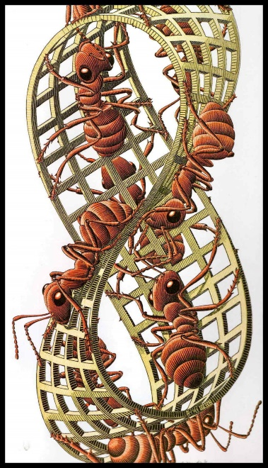
MÖBIUS

Do you want to be part of this show sign up for the audition before Wednesday 7 September!!!!!
On Thursday 8 september a list will be put up here where you can see where and when your audition will take place. Auditions will occur on 9 september, 14 september and 16 september between 17:15 and 19:00 o clock.
(these will also be the rehearsal times on Wednesdays and Fridays if you are selected for the cast)
This list is for actors only : Production, TC and Orchestra will follow
Name | Class
1.
2.
3.
4.
5.
6.
7.
8.
9.
10.
11.
12.
13.
14.
15.
16.
17.
18.
19.
20.
21.
22.
23.
24.
25.
26.
28.
29.
30.
31.
32.
33.
34.
35.
36.
37.
38.
39.
40.
41.
42.
43.
44.
45.
46.
47.
48.
49.
50.
51.
52.
53.
54.
55.
56.
57.
58.
59.
60.

